Co-Parenting Support Group

Island Therapy Solutions is introducing a new group that will be launching in January 22, 2018. Dr. Sophia Joseph Parrilla and Keila Medina, MA will be facilitating the Co-Parenting Support Group. Join us to learn and practice effective communication and cooperative skills to re-gain cohesion within the family unit!

- Where: Island Therapy Solutions
- When: January 22, 2018
- 8 sessions every Monday
- Time: 6:30-7:30p.m.

Co-Parenting Group is for individuals who:
- are divorced/separated with a child (ren)
- share the duties of parenting their child(ren)
- are unsure of the “rules” of co-parenting
- want the very best for the child(ren) to succeed

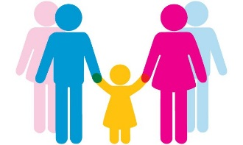
GOAL

All major insurances accepted. Sliding Scales are also available. Call 340-719-7007.

